Game Theory is a mathematical framework used to analyze strategic interactions between rational decision-makers. In the context of pricing strategies for competition and collaboration, Game Theory helps businesses understand how their pricing decisions affect not only their own profits but also the behavior of their competitors. Game theory, particularly the Prisoner's Dilemma model, can be applied to analyze competition and collaboration in digital markets. In the context of digital markets, firms often face decisions regarding whether to compete aggressively or collaborate with other players.

Competition:

In the Prisoner's Dilemma framework, each firm has an incentive to act in its own self-interest, which often leads to a scenario where both firms choose to compete aggressively.

In digital markets, this could manifest as firms engaging in price wars, aggressive marketing tactics, or developing proprietary technologies to gain a competitive edge over rivals.

However, while this might lead to short-term gains for individual firms, in the long run, it can result in a suboptimal outcome for the entire market, such as lower overall profits or market instability.

Collaboration:

Alternatively, firms in a digital market may choose to collaborate with each other to achieve mutual benefits, similar to cooperating prisoners in the Prisoner's Dilemma.

Collaboration can take various forms, including strategic alliances, joint ventures, or industry standards agreements.

By collaborating, firms can pool resources, share expertise, and collectively address market challenges, leading to improved outcomes for all participants, such as increased market share, innovation, and overall market stability.

Overall, whether in competition or collaboration, Game Theory provides valuable insights into the complex dynamics of pricing strategies, helping businesses make informed decisions to achieve their objectives.

Let understand the concept with the help of a hypothetical example

* Let's consider a hypothetical scenario in the digital streaming industry where two major Music platforms, Platform A and Platform B, are competing for market dominance. Each Platform can charge either Rs 50 or Rs 100 subscription rate per year. For simplicity, we will assume the services from each platform are identical and their costs are zero.
* If both platforms pick the same rate, they split the customer equally. If one platform prices under the other, they take the entire customer and the others get nothing. The subscription rate of Rs 50 attracts 300 customers. At Rs 100 attracts 200 customers.
* Draw up the normal form game matrix for this game. Make sure to include the players, strategies, and profits.
* Determine what happens in the Nash Equilibrium

In our example players are platform A and Platform B. Strategies are subscription of Rs 100 and Rs 50. Profits are the payoff obtained by a player by choosing a particular strategy, given the strategy chosen by another player. Thus given the given the information the payoff matrix is constructed below.

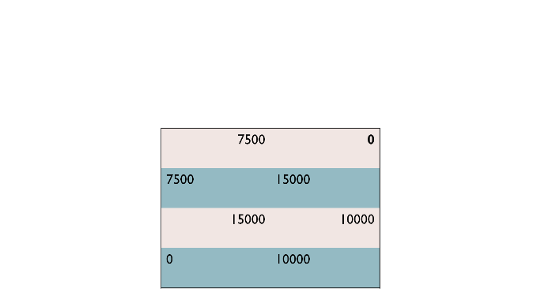

**Determining Nash Equilibrium**

A payoff [matrix](https://www.britannica.com/dictionary/matrix) is often used to help determine the optimal strategy for the players in the game. In the payoff matrix, each row represents one possible strategy for one player, and each column represents one possible strategy for the other. In the example above, the decision regarding the optimal strategy for each player would be look like follows.

Each player (platform A or platform B) will attempt to adopt the strategy (Rs 50 or Rs 100) that results in the maximum level of profit (0, 75oo, 10000, or 15000). The best outcome for the companies is to collaborate and each charges Rs 100, as this results in a total profit of only 2oooo (as opposed to 15000, if only one reduces price to Rs 50, or 7500, if both reduce price to Rs 50). This collection of strategies results in the best payoff for the players collectively. However, it is not the Nash [equilibrium](https://www.britannica.com/dictionary/equilibrium), because either company’s payoff can be improved by choosing a different strategy.

If platform A charges Rs 50, then platfom B can either charge Rs 100 and receive 0 profit or charge Rs 50 and receive profit of Rs 7500. Prisoner B’s own payoff therefore can be improved by charging Rs 50. However, one platform charging Rs 50 and the other charging Rs 100 is also not a Nash equilibrium, because the payoff of the platform who charges 100 can be improved by changing strategies. If platform A charges 100, then platform B can either charge Rs 100 and receive 10000 of profit or charge Rs 50 and receive 15000. Thus, platform B’s payoff can be improved by switching from Rs 100 to Rs 50.

The only collection of strategies in which no player’s payoff can be improved by switching strategies is if both platforms charge Rs 50. In this scenario, either platform choosing to switch strategies will result in a lower payoff. Despite this being worse for both players than if both were to charge 100, it is the Nash equilibrium. According to Nash equilibrium both the platform decided to compete and charge Rs 50.

Collaborating would be an optimal strategy for the group collectively, but individual incentives prevent this outcome from being achieved. For example, if platform A thought that platform B would collaborate (by charging Rs 100), A would have an incentive to betray and compete with B rather than to collaborate because his/her individual payoff would increase to profit of 15000 from 10000. Same for platform B.